Debayan Roy, 11000125039
Assignment 2

Objectives
- Half Subtractor using basic logic gates.
- Half Subtractor using NAND gates.
- Full Subtractor using basic logic gates.
- Full Subtractor using NAND gates.
- Full Adder using two Half Adders.
- Full Subtractor using two Half Subtractors.

A half subtractor subtracts one bit B from another bit A, giving DIFFERENCE (DIFF) and BORROW outputs. DIFF is 1 when A and B differ (XOR), and BORROW is 1 when A is 0 and B is 1 (A' · B).

A | B | DIFF | BORROW
0 | 0 | 0 | 0
0 | 1 | 1 | 1
1 | 0 | 1 | 0
1 | 1 | 0 | 0

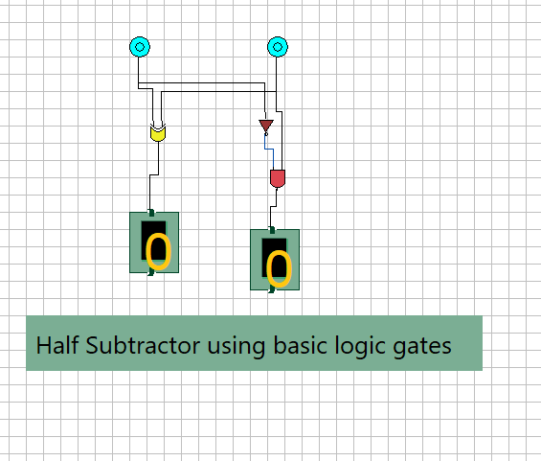

Fig. A1 — Half Subtractor: XOR gate gives DIFF, NOT(A) AND B gives BORROW. Inputs A=0,B=0 → DIFF=0, BORROW=0.

Since NAND is a universal gate, DIFF (=A⊕B) and BORROW (=A′·B) are both re-derived using NAND gates only, following the same 5-NAND XOR structure used for DIFF, plus a small NAND network for BORROW.

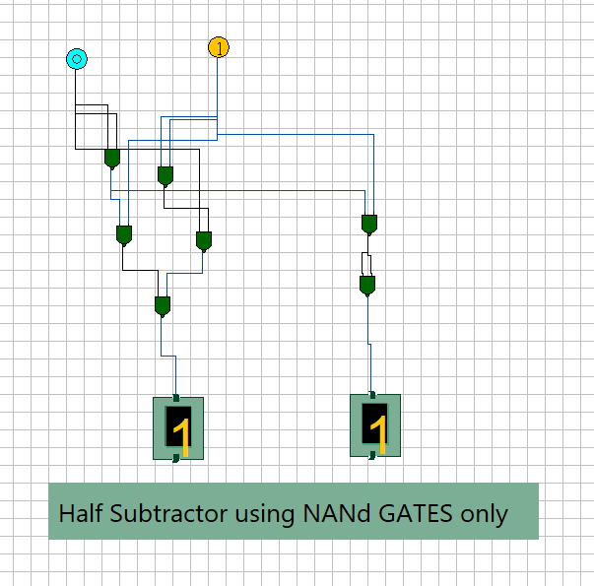

Fig. B1 — Half Subtractor built entirely with NAND gates.

A full subtractor also accepts a Borrow-IN (Bin) from a previous stage, producing DIFF and Borrow-OUT (Bout).

A | B | Bin | DIFF | Bout
0 | 0 | 0 | 0 | 0
0 | 0 | 1 | 1 | 1
0 | 1 | 0 | 1 | 1
0 | 1 | 1 | 0 | 1
1 | 0 | 0 | 1 | 0
1 | 0 | 1 | 0 | 0
1 | 1 | 0 | 0 | 0
1 | 1 | 1 | 1 | 1

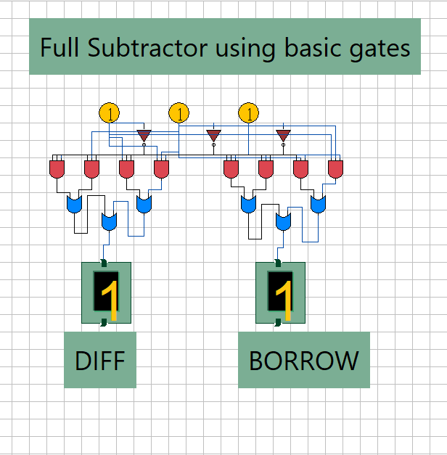

Fig. C1 — Full Subtractor with basic gates

The full subtractor is re-derived using NAND gates only. As annotated in the simulation, key intermediate NAND terms include (A′B)′ and C·(A ~ B)′-type combinations, which are recombined using the NAND identity (X′Y′)′ = X″+Y″ (equivalent to OR of X, Y) to build Bout, while a cascaded NAND-XOR structure produces DIFF.

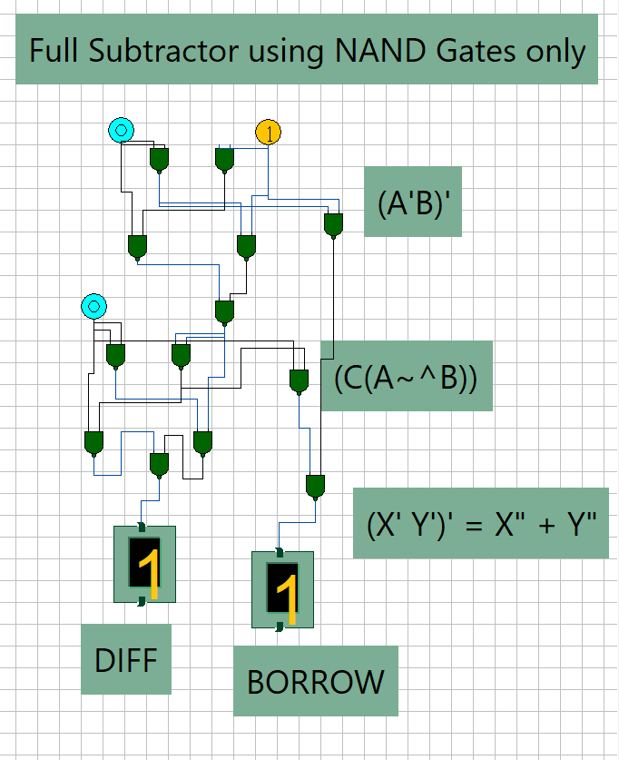

Fig. D1 — Full Subtractor implemented with NAND gates only

The first half adder adds A and B, giving an intermediate sum (A⊕B) and carry (A·B). The second half adder adds this intermediate sum to Cin, giving the final SUM and a second carry. The two carries are OR-ed to give Cout.
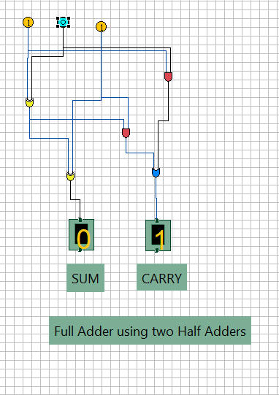

Fig. E1 — Full Adder from two cascaded Half Adders

The first half subtractor computes A−B, giving intermediate difference (A⊕B) and borrow (A′·B). The second half subtractor subtracts Bin from this intermediate difference, giving the final DIFF and a second borrow. The two borrow terms are OR-ed to give Bout.
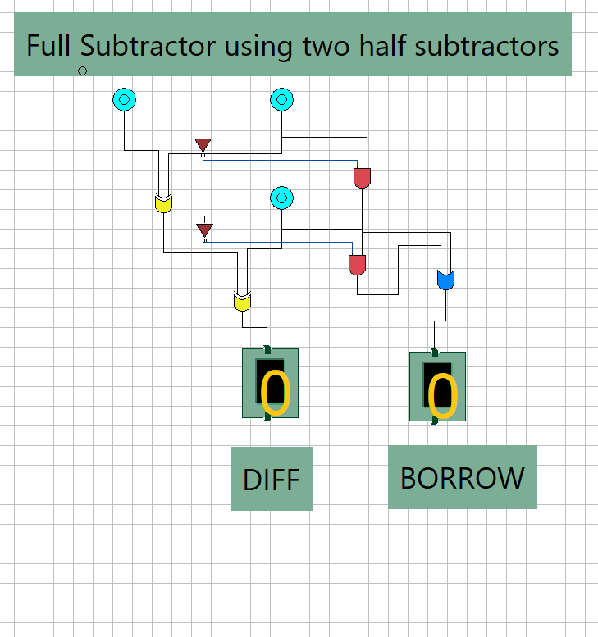

Fig. F1 — Full Subtractor from two cascaded Half Subtractors

All subtractor circuits (half and full) were successfully designed and simulated using both basic gates and NAND-only realizations, and the composite Full Adder / Full Subtractor circuits built from two half-blocks. Simulated outputs matched the theoretical truth tables in every case, confirming correct design and the universality of the NAND gate.

